Technical AI safety researcher:
Key takeaway: I think I want to work in a small research team combining multidisciplinary technical research ideas to produce empirically grounded research on tractable, neglected and important problems.
Abstract (of sorts):
What this is: In attempting to follow the exercises in How to find the right career for you, my initial list of potential careers mutated into a brain dump of venn diagrams and arrows pointing to vague concepts, roles and technical jargon. I figured the best thing to do was instead create a made-up job role that, to differing extents, included the things on the brain dump. Long story short, I accidentally created a pretty open-ended technical AI safety research proposal.
Currently, I’m interested in measuring how differences in some quantity X, that can be measured using existing mechanistic interpretability and alignment monitoring tools, cause emergent complexity in multi agent networks. This is best illustrated through an example in the form of a hypothesised bloated abstract.
Bloated Abstract: “Using a so-called swiss-cheese approach of layering CoT monitoring, probes (perhaps followed by SAEs) and J-space monitoring, we monitor how individual agents’ sense of self-identity change in a multi-agent, sandboxed, alignment experiment and how this alters the result of the sandboxed task. We extend Douglas et al.’s modification to the blackmail experiment by adding multiple agents with different self-conceptions and allow them to interact. We study:
- What proportions of which self-conceptions result in what emergent behaviours in the system i.e.
  - what the ultimate outcome of the experiment is
  - what equilibrium of self-identities, or otherwise, in the system are reached.
- What kinds of inter-agent model scheming occurs, investigated using a so-called swiss-cheese approach of layering, CoT monitoring probes /SAEs / J-space monitoring, and how this changes results.
- Extensions could include: What happens if there is a human in the loop?
Motivation:
Importance:
Model character can alter actions a model takes to pursue a goal. “Varying a model’s identity boundary can sometimes shift its behaviour as much as varying its goals. “ Douglas et al. This has been empirically proved in an adapted version of the model blackmail experiment.
The bet of Owen Cotton Barratt, paper co-author and researcher at Forethought, is that within alignment research, there is low-hanging, highly impactful, fruit. Whilst alignment policy surrounding issues humans commonly disagree on is very difficult, alignment choices where humans largely agree is, in comparison, easier. For example, broadly speaking, humas agree they would be better served to develop ai systems that make conflict resolution easier compared to making killing people easier. Yet, there is more research into military ai capabilities than conflict resolution macrostrategy expert AI. As a species, this is a poor decision if we accept, at some point, AI systems will continue to get more capable and more autonomous. It is not unreasonable to suggest reducing the gap in capability between the frontier military and conflict resolution AI systems would buy us valuable time to work on alignment, governance and interpretability. For lose visual purposes, picture the figure below;
mi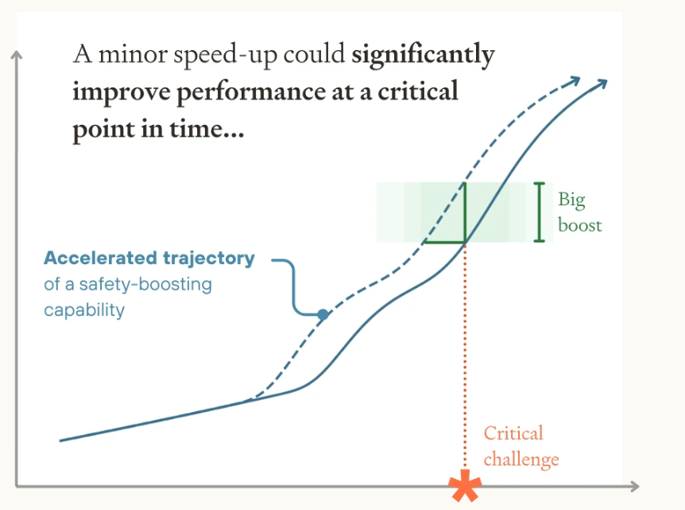
Fig 1: Forethought’s ‘minor differences in speed up could be significant’ figure.
Therefore, especially since we are uncertain on AI capability timelines, it makes sense to reduce this gap between military capabilities and conflict-resolution capabilities.
So, to link this back to the bloated abstract, If AI character generates tangible impact on goal outcome, it doesn’t seem unreasonable to reach the conclusion, given we currently exist at a time in AI capabilities where we can not only study these characters, but engineer closer to our liking based on the results of safe sandboxed experiments, we probably should. We probably should in ways that, broadly speaking, lead to generally safer outcomes in ways most people don’t have a problem with. This can be done. Most people would agree altering a model’s internal character self-assessment to increase its situational awareness in ways that seem to make it more safely goal-aligned with no compromise to day-to-day performance, is a low hanging alignment fruit. To do so, we have to perform experiments like the one detailed in the bloated thesis.
The reason the bloated thesis chooses to focus on multi-agent systems is a combination of my own interest, and that the emergent complexity from character evaluation is, identified by Douglas et al., a recommended and neglected research area.
Neglect:
The last sentence in the Douglas et al. abstract is “We end with key recommendations: treat affordances as identity-shaping choices, pay attention to emergent consequences of individual identities at scale, and help AIs develop coherent, cooperative self-conceptions.”
As far as I can tell, pay[ing] attention to emergent consequences of individual identities at scale, and in turn the following points aren’t actually studied empirically within this study. My research is preliminary currently, however ChatGPT-sol-5.6-high-reasoning ‘s reading of the paper structure broadly agrees, stating:
“Empirical observations→framework about identity→extrapolation to future emergence→design recommendations
It signals that the authors think their small-scale results justify a broader research programme about identity dynamics, even though they have not yet directly shown:”
Furthermore, on the Forethought website, the top suggestion under their website subheading “act” is the following:
“AI character evaluation. Start an independent org to evaluate and stress-test AI character traits (epistemic integrity, prosociality, appropriate refusals), hold developers accountable against their own model specs / constitutions, and suggest and incentivise improvements to the specs.”
I think one would be hard pressed to find someone who disagrees with the fact that emergent properties under multi-agent interaction is a key consideration for AI character evaluation.
Soft neglect factors
Perhaps my biggest compliment to the fellowship is, since starting, I’ve been privileged to enjoy some of the most interesting conversations I’ve ever had. One of which was with Noah y Seigal at the Sentio social after class on 15.09.26. Noah’s take was that AI safety is no longer as neglected as it was 10 years ago. What is more neglected, is emergent properties that map most naturally to the concept of self. He recommended reading the new anthropic global workspace (J-space) paper. Whereas his intrigue with the results were more consciousness related, mine are more on the implications for alignment studies as a new mech interpretability tool. I concede, the same paper came up in my BlueDot technical AI safety paper the next day. I am unsure if the proximity of the events is disproportionality adding hype to my bet on the paper’s usefulness. Nevertheless, I’d posit it is the job of a technical ai safety researcher to find this out empirically.
Quite frankly, from talking to Noah, reading the global workspace paper, “ Douglas et al., reading around the work of Forethought to prep for an EAG 1-1 with Owen Cotton Barrat, a coffee I had with Lysander Mawby discussing the for-profit side of mech interp and open questions in the field through a general Impact first osmosis, my research taste gut tells me measuring how differences in some character-related quantity X, measured using mechanistic interpretability, causes emergent complexity in multi agent networks research is important and neglected. This leaves two questions: Is it tractable? Is it a tractable career direction for me, at this time?
Tractability
I posit within the bloated abstract, new, tractable results can be extracted. Some initial candidates:
- A table of which mech interp techniques identify (and which ones miss) what kinds of scheming in the adapted blackmail experiment case. (This likely exists. But it may not, I am often surprised how many seemingly open goals exist.)
- What kind of distributions or what kind of scalars determine equilibriums in a multi-agent setting and how robust are these scalars and distributions to perturbations within a chosen the experimental set up?
- How robust results are across different initial combinations of character types scheming propensities.
The specifics here deviate from the original intended purpose of this exercise.
Personal Fit
To paraphrase, Holden Karnoksy: ‘I know this might p*ss off some EAs, but given the level of uncertainty around choosing a career, I tend to advise people to do something they think personally, relative to other things they could be doing, they’d do well.’
I think, relative to other things I could be doing in the world, technical, multi-disciplinary researcher suits my skillset. More specifically, I think searching for high-impact research in non-conventional places, once I have accrued more experience, would be a good fit.
My thought process for this is the following: There will be more dedicated people than me, with a better natural aptitude for pure mechanistic interpretability research. The same can be said for sentient futures, complexity economics, forecasting, mathematical philosophy and probably all areas of technical governance. I want to optimise the impact these researchers can have by being a connecting node between researchers. Someone less clued up on all nodes in a multi-disciplinary research team but able to facilitate the best communication between them. To act as a sounding board for individual researchers with enough technical background and context to be more helpful than an llm. To read literature reviews and look for the best people external to the project to add. To actively work on how the research agenda might need to adjust its theory of impact. As far as I’m aware, the role I’m describing now is a senior one. Thankfully, I love being mentored and doing nitty-gritty technical research. I think this is why a PhD in complex systems appealed to me: still being mentored, tooling up on the technical science of how things connect, working in multi-disciplinary teams.
Uncertainty
- How one gains the appropriate research priors required to eventually be working on a project even remotely like the bloated abstract.
- That a PhD length of time isn’t required. Timelines aside, is the speed of upskilling in the AI safety industry a bit narcissistic on the amount of time it takes to gain expertise? Is the bet to learn by doing and in 3 years be ahead of where you would be if you just leaving a PhD? This I can believe.
- To what extent this is all techno-futurist hype I’m falling for. If it is, what does that change? How does participating in the AI safety space help or hinder billionaires that ultimately fund the work?
- How good my research taste is. Are my ideas quack science? Has continuous interaction with sycophantic llms blinded me to developing appropriate critical faculties since I’ve been without regular technical supervision?
- Is endlessly applying for insanely competitive fellowships that cultivate this even worth it? The expected value of completing an application is so low when one accounts for the finite-time they can be unemployed for. For example, Jason Tang (Bluedot technical AI safety) said applying for MATS is probably of a waste of time. When it began the acceptance rate was 30-50%. What do I do?
- My strength relative to people on my physics cohort wasn’t maths skill or dedication, it was agency to pursue questions no one else was thinking about. I could usually, in no small part due to communication and soft skills, persuade people these ideas weren’t crazy. Given this combination of technical, soft-skills and communication, is this the most high impact, fulfilling thing I could be doing?
Skills required
{Research taste, convincing others your idea is worth doing, marketing research, not sacrificing high impactness of research for career ladder climbing and maintain integrity, scout mindset, learning from smart people without slowing them down, offering value in unique ways to aid more talented people, large abstract thinking RAM, being resistant to galaxy brain, accepting sometimes the most high impact thing you can do is produce results to aid governance work, being able to sacrifice mathematical beauty for ruthlessly high impact papers}

